You should wait until tournament is complete. But for demo purposes, I will do current tournament in progress.

1. Find tournament you are pulling results from

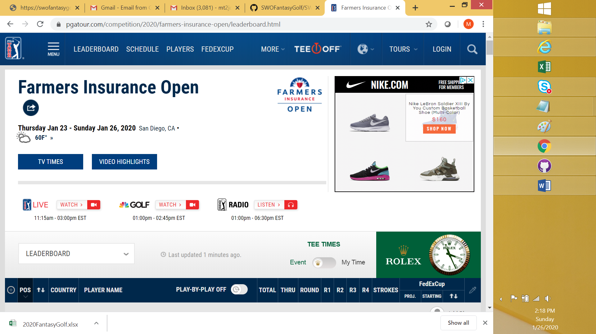

1. Select all rows before the cut-line

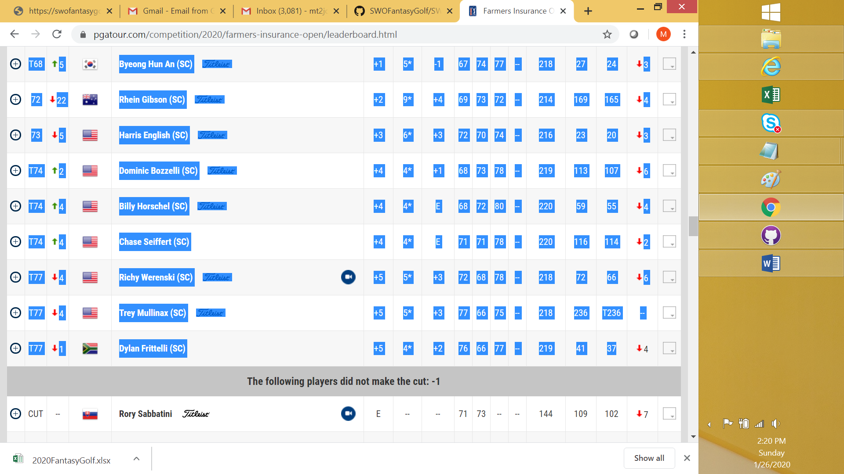

1. Copy selection and paste into new empty Excel spreadsheet.

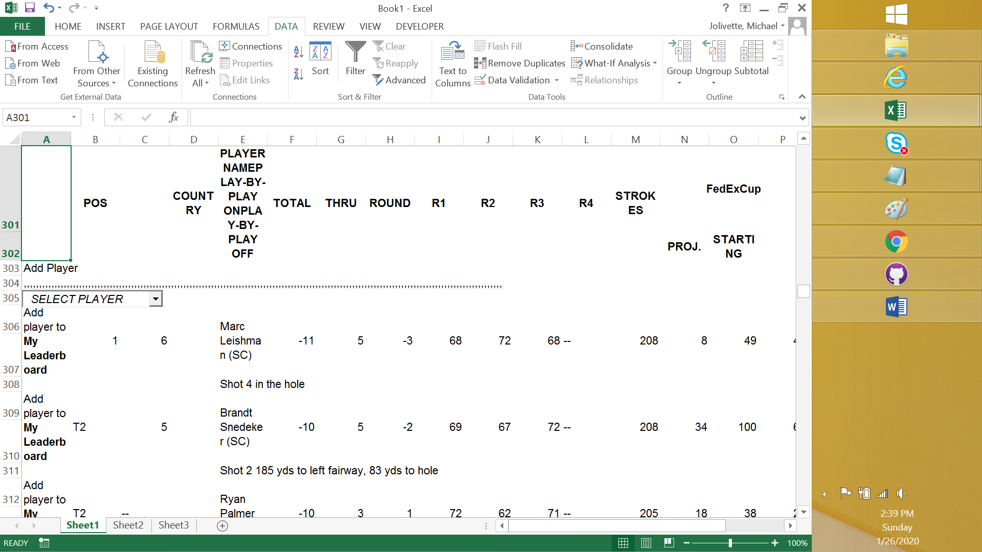

1. Copy all rows with Excel and paste into Notepad

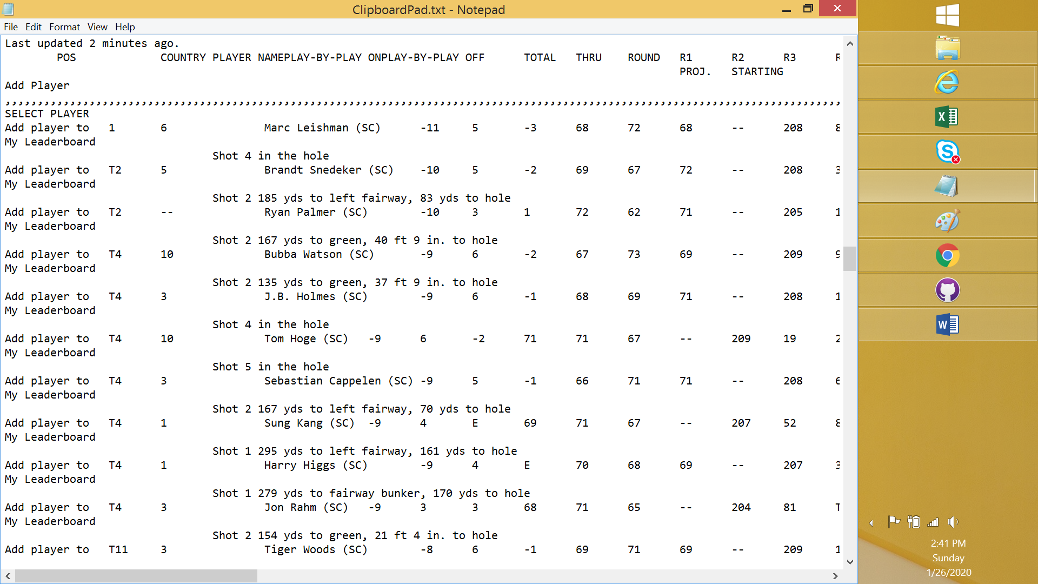

1. Select and Copy/Paste back into a new tab in Excel

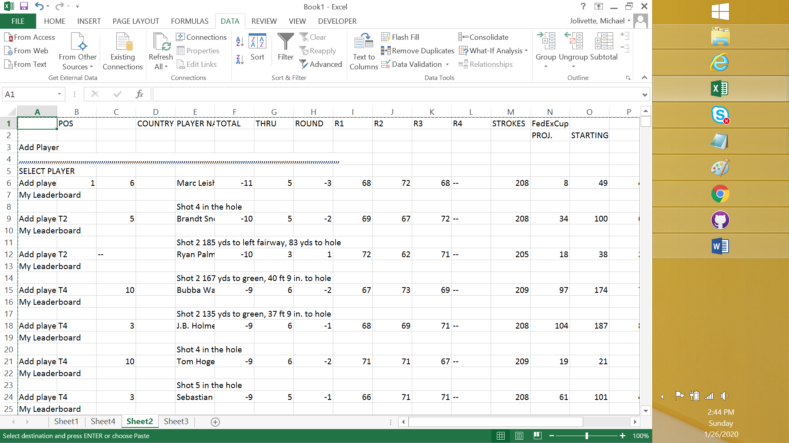

1. Delete all columns not related to the following values:

|  |  |  |  |  |  |  |  |  |  |
| --- | --- | --- | --- | --- | --- | --- | --- | --- | --- |
| POS | PLAYER Name | TOTAL | THRU | ROUND | R1 | R2 | R3 | R4 | STROKES |

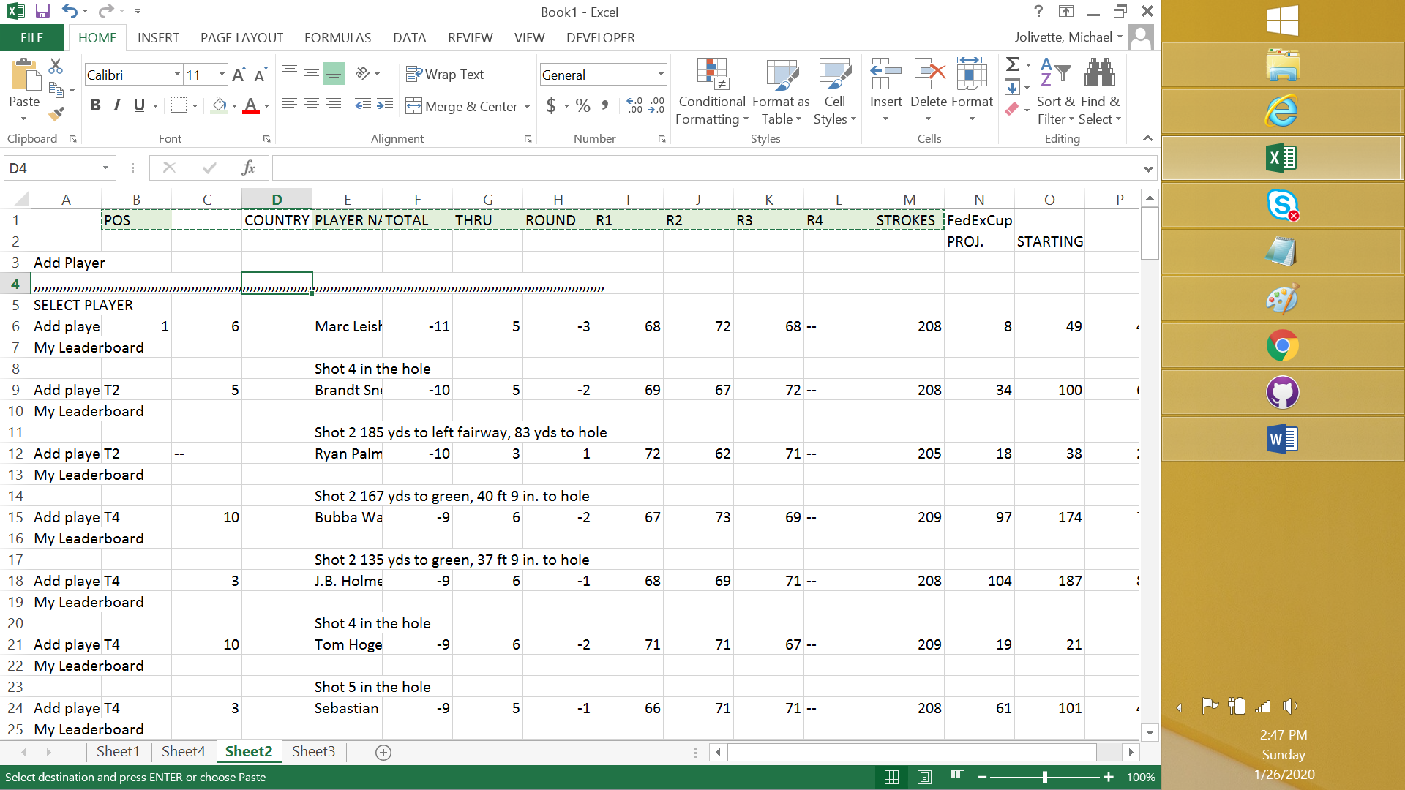

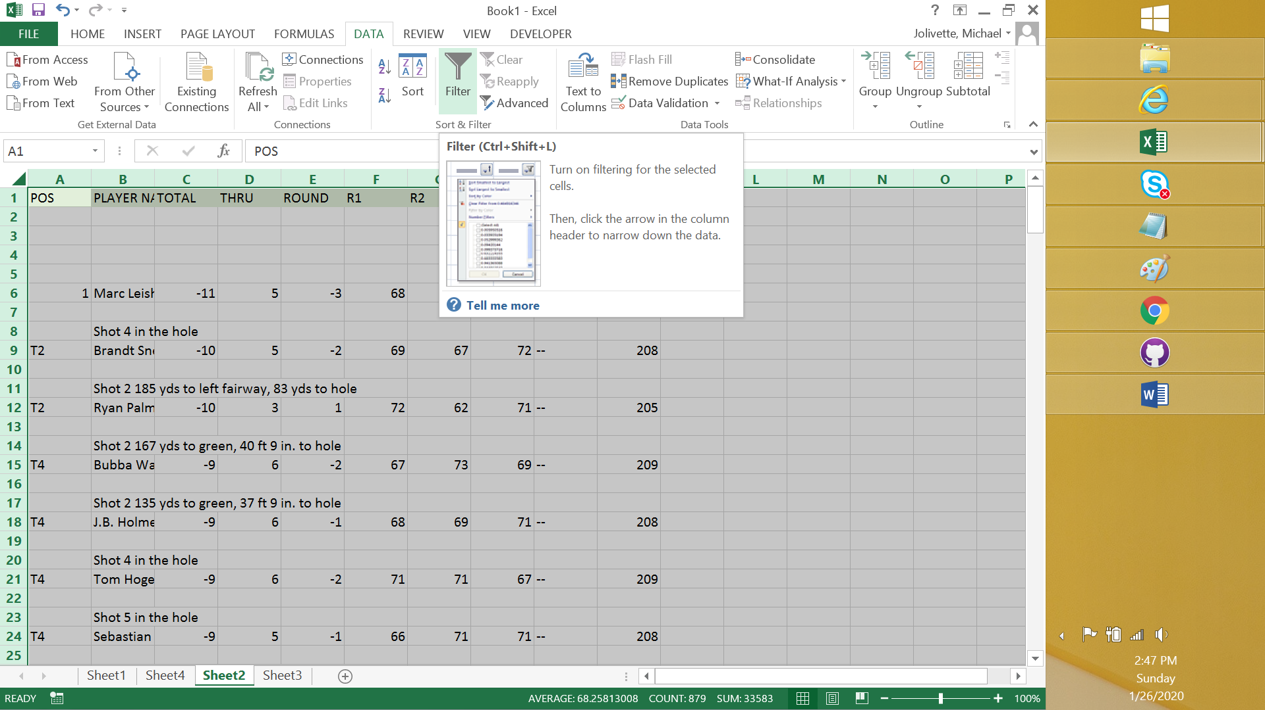

1. Filter so you only get relevant data needed for results

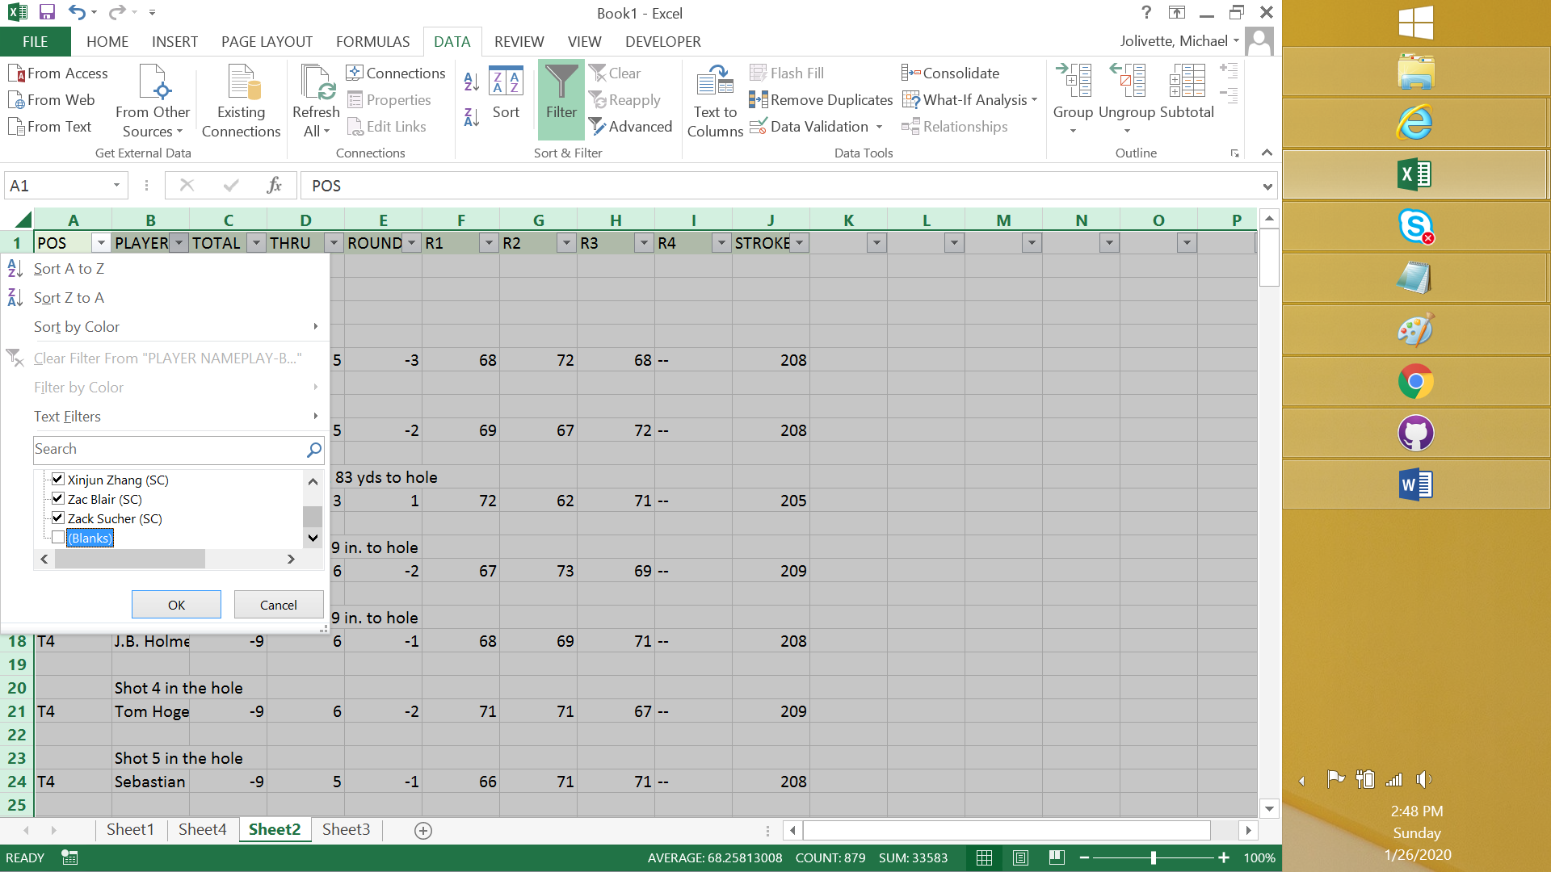

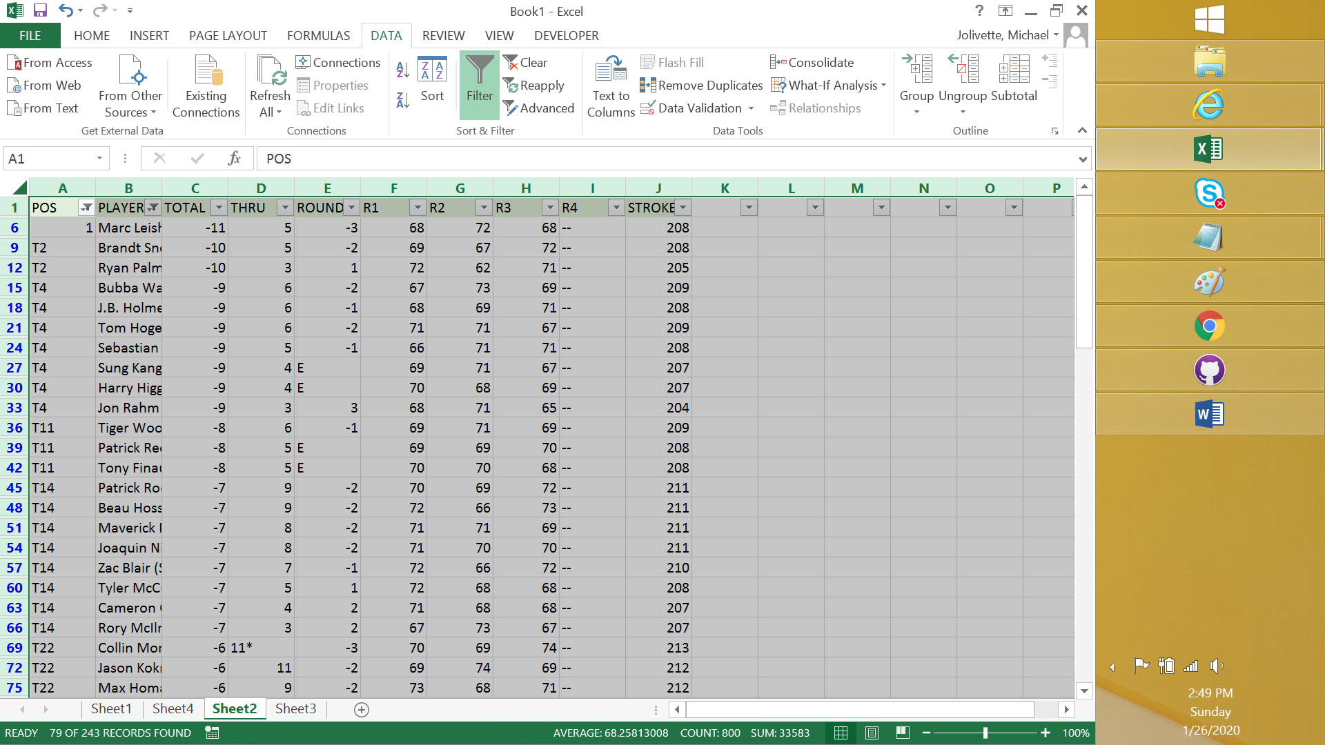

8 Copy relevant data into notepad and clean up in extra values entered into Player Name .. for example “(SC)”

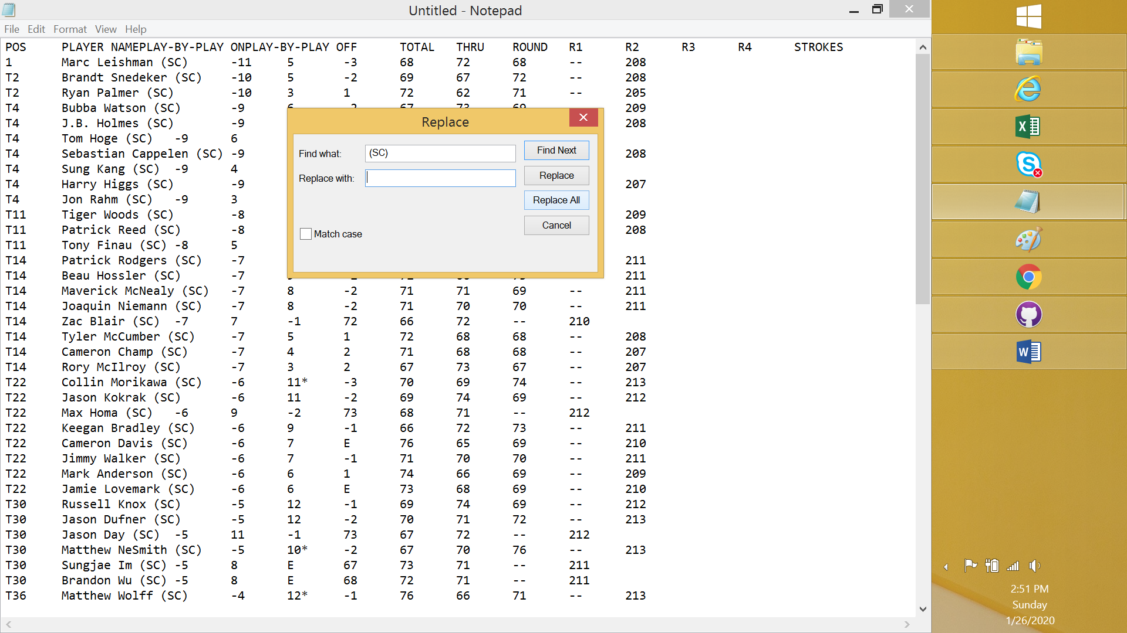

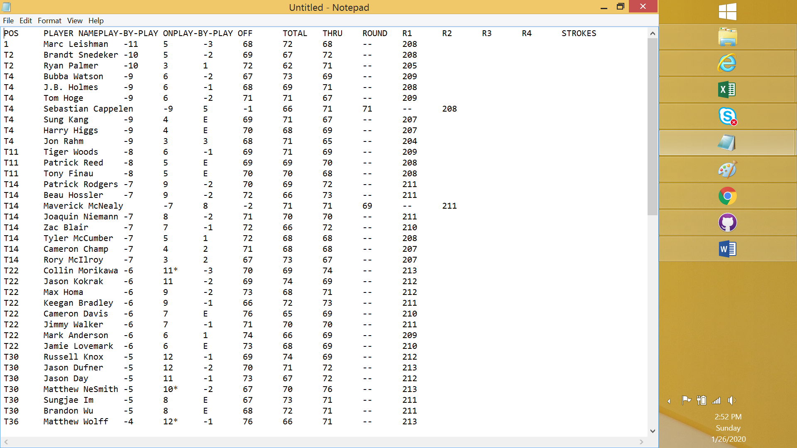

9. Copy/Paste player scores into the SavePGAResults Template

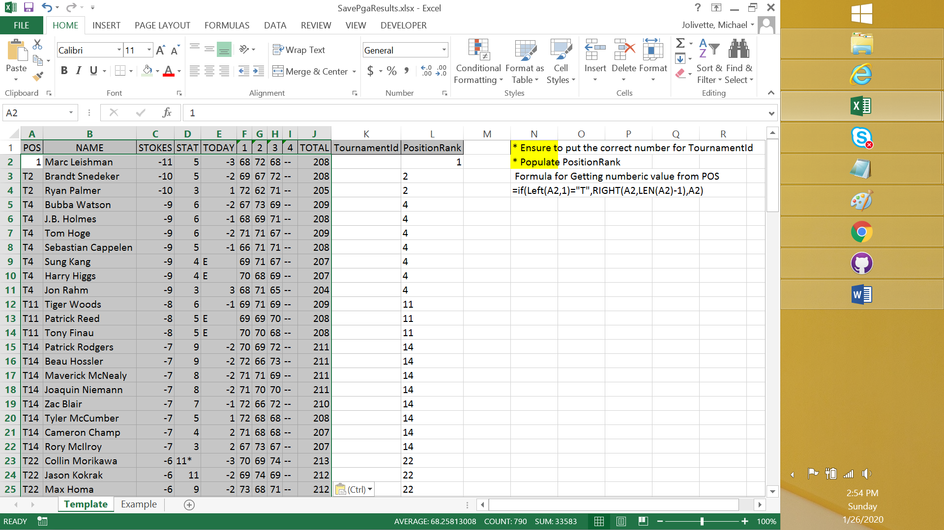

10. Double check values don’t have any problems. (sometimes extra space or character slip in.

Also populate the TournamentID value that corresponds to current tournament

11. Copy/Paste values into MS Access Table LeaderLoad

